INTRODUCTION

Antenatal care is a care of the particular form of medical care given to pregnant women and babies starting from the time of conception up to the delivery of the baby. Almost 90% of maternal deaths occur in developing countries. Maternal mortality in Bangladesh was 320 per 100,000 live births between the year of 1998 & 2000. Bangladeshi women reported low utilization of ANC; approximately 52% of women received ANC from medically trained personnel in 2007. MMR and IMR according to Bangladesh Bureau of Statistics 2015 report 1.7 and 41 accordingly. Four pillars of WHO Safe Motherhood Initiative include:

* provision of ANC facilities
* clean & safe delivery
* family planning & contraception
* provision of emergency obstetric care.

Antenatal checkup helps to solve problem if any in its early stage and thus prevents many morbidities and loss of maternal lives. Eclampsia is a fatal complication of pregnancy causing maternal death and child too. It could be prevented by early detection by simple examinations like Ankle oedema, raised BP & test like heat coagulation test for Proteinuria. Conditions like Placenta previa, Threatened abortion if taken proper steps could save the life of mothers & their babies as well. Besides mother can also have STDs like Gonorrhoea, Syphilis, Hepatitis-B, AIDS etc. Preset treatment modalities can save the child from morbidities and mortalities. [Erythroblastosis foetalis](https://www.google.com/search?biw=1280&bih=923&q=Erythroblastosis+fetalis&spell=1&sa=X&ei=LatSVfixOM2LuASr9oHgDg&ved=0CBkQvwUoAA) is another one can be prevented on successive pregnancies if a woman with Rh negative blood having her husband with Rh positive blood with administration of Anti-D if the baby found Rh positive.

Woman’s health & behavior in pregnancy affect her baby on both ways. A poor diet, smoking, intake of alcohol, chronic illness can hamper baby’s development. Antenatal care is thus absolutely necessary because it ensures that the mother remains healthy & fit enough. Moreover certain drugs like aspirin in first trimester of pregnancy can impair proper development of foetus resulting in cleft palate, hare lip etc. Pregnant woman requires extra food & vitamins. Proper dietary advice by a Doctor is essential for the mother & the baby as well. Developmental anomalies like Spina-bifida could be prevented by giving folic acid during pregnancy. To deal effectively with conditions that could arise during pregnancy WHO recommended an ideal number of fourteen antenatal visits and a minimum of four. In case of minimum number of visits it will be on 16th, 24-28th, 32 and 36th weeks.

It is easy to motivate mothers for family planning during pregnancy. Family planning measures is of immense importance for health and safety of both mother and child of a smallish developing country like Bangladesh with 160 million peoples.

**OBJECTIVES OF THE STUDY**

**General Objective:**

To know the knowledge & practice of rural mothers regarding ante-natal care in Tikorpara andPhulbari village of Golapgonj upazila.

**Specific Objectives:**

1. To see knowledge of rural mothers regarding ante-natal care.
2. To determine practice of health care of the respondents during ante-natal period.
3. To know the reproductive status of the respondents.
4. To know the family planning practice characteristic of the respondents.
5. To obtain socio-economic data of the respondents

METHODOLOGY

* **Type of study**: Cross sectional type of descriptive study.
* **Study place:** Tikorpara andPhulbari village of Golapganj upazila, Sylhet.
* **Study period:** May 2015
* **Study population:** All the mothers having their last child of five years or less of Tikorpara and Phulbari village.
* **Sample size:** 150
* **Sampling technique:** Non-probability purposive sampling was done.
* **Data collection instrument:** A semi-structured questionnaire was used to collect data.
* **Data collection technique:** Data was collected from the respondents by the researchers (students) themselves by face to face interview.
* **Data analysis:** On completion of data collection these were screened out for errors. Data were tabulated after verification & was analysed by simple statistical methods using a computer.

RESULTS

In order to have an idea about the knowledge and practice of rural mothers regarding antenatal care a study was conducted and the related information was collected using a questionnaire. Now, the study results are being stated hereafter in the following pages.

**Table No –1: Distribution of respondents according to Age.**

|  |  |  |
| --- | --- | --- |
| **Age of the Respondents (Years)** | **Total Number** | **Percentage (%)** |
| ≤18 | 2 | 01.33 |
| 19-23 | 35 | 23.33 |
| 24-28 | 68 | 45.33 |
| 29-33 | 36 | 24.00 |
| ≥ 34 | 9 | 06.00 |
| **Total** | **150** | **100** |

The table shows that 45.33% of the mothers aged 24-28 years, 24% of 29-33 years, 23.33% of 19-23 years, 6% of ≥ 34 years and 1.33% mothers found ≤18years.

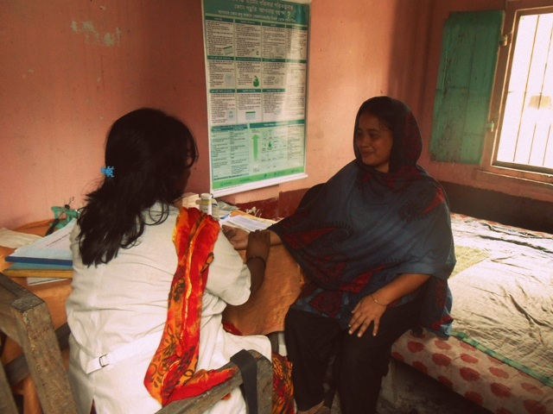

**Figure-01: Educational status of Respondents.**

The above pie diagram reveals that 8.67% mothers were illiterate, 34% studied up to primary level, 48.67% studied up to secondary level and 8.67% studied up to higher secondary & above level.

**Figure-02: Distribution of respondents by Occupation.**

This pie diagram shows that the highest number of respondents were housewives 98.67% and 1.33% of them were service holders.

**Figure-3: Distribution of Respondent's Husband by their Occupation**

This simple bar diagram shows that the highest numbers of husbands were different type of occupation 43.34%, businessman 26.67%, service holders 14.67% and working abroad 12.67% and 2.67% was farmer.

**Table No-2: Monthly Family income of the Respondents**

|  |  |  |
| --- | --- | --- |
| **Amount in Taka** | **Total Number** | **Percentage (%)** |
| ≤3000 | 12 | 8 |
| 3000-6000 | 36 | 24 |
| 6001-9000 | 39 | 26 |
| 9001-12000 | 36 | 24 |
| ≥12000 | 27 | 18 |
| **Total** | **150** | **100** |

The table shows that 26% families income families income is 6001-9000 taka, 24% families income is between 3000-6000 taka, 24% families income is between 9001-12000 taka, 18% families income is above 12000 taka & only 8% is less than 3000 taka.

**Table No-3: Distribution of respondents according to the Number of Children in their families.**

|  |  |  |
| --- | --- | --- |
| **Total number of Children** | **Total Number** | **Percentage (%)** |
| 1 | 57 | 38 |
| 2 | 47 | 31.33 |
| 3 | 26 | 17.33 |
| 4 | 14 | 9.33 |
| >4 | 6 | 4 |
| **Total** | **150** | **100** |

The table shows that 38% have 1child, 31.33% have 2 child, 17.33% have 3 child, 9.33% have 4 child and 4% have more than 4child.

**Table No-4: Respondents according to the Age of last Child**

|  |  |  |
| --- | --- | --- |
| **Age of the last Child (Years)** | **Total Number** | **Percentage (%)** |
| 0-1 | 31 | 20.67 |
| 1-2 | 31 | 20.67 |
| 2-3 | 35 | 23.33 |
| 3-4 | 23 | 15.33 |
| 4-5 | 30 | 20 |
| **Total** | **150** | **100** |

The table shows that 23.33% of are between 2-3 years, 20.67% of are between 0-1 years and 20.67% of are between 1-2 years, 20% of are between 4-5 years and 15.33% of are between 3-4 years.

**Table No-5: Distribution of mothers by the Age at Menarche**

|  |  |  |
| --- | --- | --- |
| **Age Distribution (Years)** | **Total Number** | **Percentage (%)** |
| ≤12 | 78 | 52 |
| 13-14 | 61 | 40.67 |
| >14 | 11 | 7.33 |
| **Total** | **150** | **100** |

The table shows that 40.67% of the mother had their menarche between the 13-14 years, 52% of before or at 12 years and 7.33% of after 14 years.

**Table No-6: Distribution of respondents by Age at Marriage**

|  |  |  |
| --- | --- | --- |
| **Age of Distribution (Years)** | **Total Number** | **Percentage (%)** |
| ≤18 | 75 | 50 |
| 19-20 | 50 | 33.33 |
| 21-22 | 18 | 12 |
| >22 | 7 | 4.67 |
| **Total** | **150** | **100** |

The table shows that 50% respondents got married before or at 18 years, 33.33% at age between 19-20 years, 12% at age 21-22 years and 4.67% got married after 22 years.

**Table No-7: Distribution of respondents according to the age of First Child birth**

|  |  |  |
| --- | --- | --- |
| **Age Distribution (Years)** | **Total Number** | **Percentage (%)** |
| ≤18 | 33 | 22 |
| 19-23 | 100 | 67 |
| 24-28 | 15 | 10 |
| 29-33 | 02 | 1 |
| ≥34 | 00 | 0 |
| **Total** | **150** | **100** |

The table shows that 67% of mothers had their first child at 19-23 years, 22% of mothers below or at 18 years, 10% of mothers at 24-28 years, 1% of mothers at 29-33 years and no mother after 34 years.

**Figure No-04: Contraceptives used by the respondents**

The pie diagram shows that 70% of mothers used contraceptives and 30% don’t.

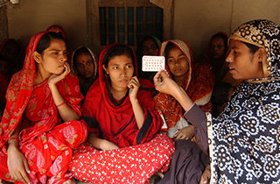

**Table No-8: Distribution of respondents by type of Contraceptives they are using (n=115)**

|  |  |  |
| --- | --- | --- |
| **Type of contraceptive** | **Frequency** | **Percentage (%)** |
| OCP | 71 | 61.74 |
| Condom | 29 | 25.22 |
| Injectable | 7 | 6.09 |
| Cu-T | 2 | 1.74 |
| Norplant | 4 | 3.48 |
| Permanent Method | 2 | 1.74 |
| **Total** | **115** | **100** |

The table shows that 61.74% uses combined oral pill, 25.22% uses condom and 6.09% uses Injectable, 3.48% uses norplant, 1.74% uses Cu-T and 1.74% uses permanent method.

**Figure-05: Distribution of respondents according to the knowledge of importance of Antenatal care**

The pie diagram shows that 98.67% of the mothers have knowledge about the importance of antenatal care and the remaining 1.33% do not.

**Figure-06: Knowledge of respondents about the time of receiving Antenatal care**

From the above bar diagram it is revealed that 64.86% of mothers had the knowledge of receiving antenatal care from conception to delivery, 33.11% at as soon as known pregnancy, 1.35% at before delivery and 0.68% after delivery.

**Table No-9: Knowledge of mothers about recommended minimum Antenatal visits**

|  |  |  |
| --- | --- | --- |
| **Number of visits** | **Total Number** | **Percentage (%)** |
| One | 2 | 1.33 |
| Two | 13 | 8.67 |
| Three | 28 | 18.67 |
| Four | 100 | 66.67 |
| Don't Know | 7 | 4.67 |
| **Total** | **150** | **100** |

Table shows that 66.67% of the mothers know that the minimum antenatal visit is four, 18.67% know it is three, 8.67% know it is two, 1.33% know it is one and 4.67% have no idea.

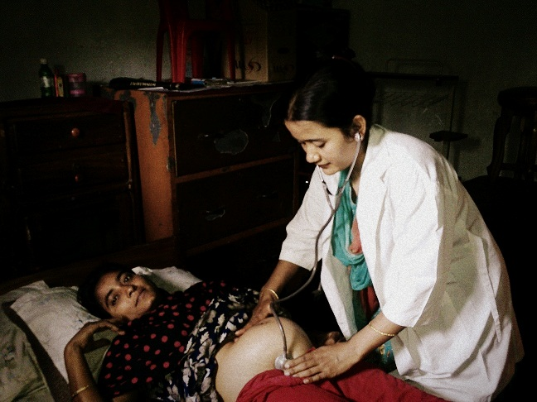

**Figure-07: Number of Antenatal visits received by the respondents during the Last pregnancy**

The bar diagram shows that during their last pregnancy, 53.33% of mothers went for antenatal check-up four times, 23.33% went three times, 10.67% went twice and 8.67% went once & 0.67% went more than four times . The remaining 3.33% of mothers did not go for antenatal check-up during their last pregnancy.

**Table No-10: Knowledge about the places where Antenatal care is given**

|  |  |  |
| --- | --- | --- |
| **Center of visit** | **Total Number** | **Percentage (%)** |
| Upazila health complex | 43 | 28.67 |
| Union sub-center | 8 | 5.33 |
| Community clinic | 43 | 28.67 |
| Private | 52 | 34.67 |
| At home by trained Dai | 4 | 2.67 |
| **Total** | **150** | **100** |

Table shows that 34.67% known about the antenatal care given from private sector, 28.67% from upazila health complex, 28.67% from community clinic, 5.33% from union sub center and 2.67% from at home by trained dai.

**Table No-11: Places where respondents received Antenatal care**

|  |  |  |
| --- | --- | --- |
| **Place** | **Total Number** | **Percentage (%)** |
| Upazila health complex | 19 | 12.67 |
| Union sub-center | 3 | 2 |
| Community clinic | 27 | 18 |
| Private | 89 | 59.33 |
| At home by trained dai | 3 | 2 |
| Others | 8 | 5.33 |
| Not received | 1 | 0.67 |
| **Total** | **150** | **100** |

Table shows that 59.33% received antenatal care from private sector, 18% from community clinic, 12.67% from upazila health complex, 5.33% from other media, 2% from union sub center, 2% from at home by trained dai and only 0.67% not received antenatal care.

**Table No-12: Distribution of respondents according to Care providers**

|  |  |  |
| --- | --- | --- |
| **Care Provider** | **Total Number** | **Percentage (%)** |
| Doctor | 135 | 90 |
| Paramedics | 4 | 2.67 |
| Trained Dai | 5 | 3.33 |
| Others | 6 | 4 |
| **Total** | **150** | **100** |

Table show that 90% deliveries were conducted by doctors, 3.33% was conducted by trained dai, 3.33% was conducted by paramedics and rest 4% from others.

**Figure-08: Respondents according to TT vaccination status.**

The pie diagram shows that 97.33% mothers taken TT vaccine and 2.33% did not take.

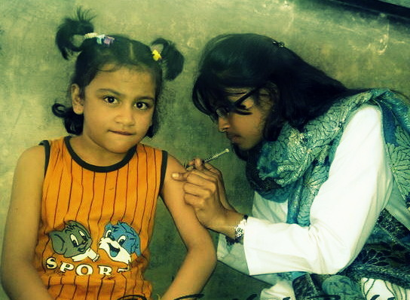

**Table No-13: Distribution of respondents according to time of TT vaccine they received (n=146)**

|  |  |  |
| --- | --- | --- |
| **Number of TT vaccine** | **Total Number** | **Percentage (%)** |
| 5 TT vaccine from 15 years | 79 | 54.11 |
| <5 TT vaccine from 15 years | 15 | 10.27 |
| 2 TT vaccine during each pregnancy | 47 | 32.19 |
| <2 TT vaccine during each pregnancy | 5 | 3.42 |
| **Total** | **146** | **100** |

Table shows that 54.11% mother taken five TT vaccines from 15 years, 32.19% taken two TT vaccine during pregnancy, 10.27% taken less than five TT vaccines from 15 years and 3.42% taken less than two TT vaccine during pregnancy .

**Table No-14: Knowledge about the Warning signs of Pregnancy**

**(n=443)**

|  |  |  |
| --- | --- | --- |
| **Warning Signs** | **Total Number** | **Percentage (%)** |
| Vaginal bleeding | 88 | 58.67 |
| Leg oedema | 105 | 70 |
| Convulsion | 88 | 58.67 |
| Blurring of vision | 56 | 37.30 |
| Headache | 61 | 40.67 |
| High fever (>3 days) | 37 | 24.67 |
| Others | 8 | 5.3 |

Table shows that 70% mother known about leg oedema, 58.67% known about vaginal bleeding, 58.67% known about convulsion, 4.67% known about headache, 37.30% known about blurring of vision, 24.67% known about high fever & 5.3% known about others..

**Table No-15: Knowledge of respondents regarding Antenatal complications (n=183)**

|  |  |  |
| --- | --- | --- |
| **Complications** | **Total Number** | **Percentage (%)** |
| Anaemia | 39 | 21.31 |
| Hypertension | 29 | 15.85 |
| Threatened abortion | 4 | 2.19 |
| Severe vomiting | 46 | 25.13 |
| Others | 37 | 20.20 |
| No complication | 28 | 15.30 |

Table shows that 25.13% suffered from severe vomiting, 21.31% from anemia, 15.85% from hypertension. 2.19 from threatened abortion, 20.2%

suffered from others complication and 15.3% did not suffer any complication.

T**able No. – 16: Place of delivery of last child**

|  |  |  |
| --- | --- | --- |
| **Place of delivery** | **Number** | **Percentage** |
| Home | 58 | 38.67 |
| Hospital | 92 | 61.33 |
| **Total** | **150** | **100** |

This table shows 38.67% mothers delivered their child in their residence and 61.33% mothers in hospital.

**Table No. – 17: Mode of delivery of last child**

|  |  |  |
| --- | --- | --- |
| **Mode** | **Number** | **Percentage** |
| Normal Vaginal Delivery | 101 | 67.33 |
| Caesarian Section | 49 | 32.67 |
| **Total** | **150** | **100** |

This table shows that 67.33% mothers had normal vaginal delivery and 32.67% mothers went caesarian section to deliver their child.

DISCUSSION

Antenatal care is given priority in the state's health policy worldwide. This cross sectional descriptive study was carried out to have an idea regarding the knowledge and practice of antenatal care of rural mothers. Hundred and fifty mothers having their last child of five years or less were interviewed.

**Socio-demographic information of the respondent:**

In this study regarding the age, the highest number of the respondents belongs to the age group of 24-28 years (45.33%), 29-33 & 19-23 age groups constitute almost same percentage 24% & 23.33% respectively, only 6% mothers are 34 years or above. Although lowest age of marriage in Bangladesh is 18 years, 1.33% mothers are at or below the age of 18. (Ref: Tab.1)

Regarding the occupation, 93.10% respondents are housewives. Among them, highest number of respondents i.e. 54.31% studied up to secondary level which is much higher than national literacy rate (Bangladesh literacy rate is 26.29%, according to Bangladesh Literacy Survey 2010). 29.31% respondents studied up to primary level which is almost near to the national literacy rate 28.30%. Our survey shows that 7.75% studied up to higher secondary or above where national literacy rate is 3.81% and less but not negligible 9.40% are illiterate. So, in contrast to Bangladesh Literacy Survey, rural mother’s educational status in these two villages is satisfactory. (Ref: Fig. 1&2).

Regarding occupation of the respondent’s husbands 31.03% are day labourer, 29.31% are businessmen, 17.24% are working abroad, 17.24% are service holder and 5.17% are engaged in other occupations. Regarding the monthly income of the respondent’s husbands, 23.28% earn 3000-6000taka, 22.42% earn below 3000taka, 19.83% earn 12000-15000taka and 18.11% earn 9000-12000taka. It reveals that 22.42% of respondent’s husbands earn less than 36,000 taka per year which is far less then national (53,236 taka, according to Bangladesh Bureau Survey per capita GDP 2011) and another 23.28% earn 36,000-72,000 taka indicates a few more fall below the level of poverty. (Ref: Tab.2 & Fig.3) About one third of 46 (30.66%) of the respondents have 3 or more children already; 47 of them have 2 children, constitutes 31.33% of the total respondents; however 57 (38%) have one child. Considering their age they might have more children though to their reproductive ages left if not family planning motivational program is farther strengthen. (Ref: Tab no: 3&4)

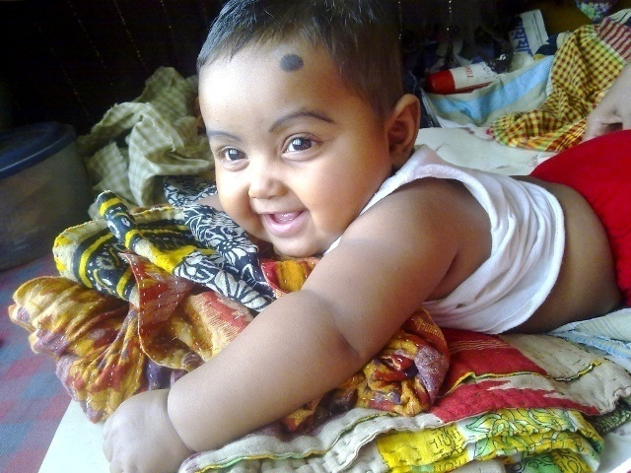

Regarding menarche the highest number (52%) of the age group below or at 18 years. Most of respondents (50%) got married at the age or below 18 years. 4.67% at the age above 22 years, which is not satisfactory regarding legislation of age at marriage (for female age at marriage 18 years) of Bangladesh Government. During delivery of 1st child, majority of the respondents (67%) are in the age group of 19-23 years. Another study showed that south Asian countries have high proportion of teenage pregnancies, since early marriage is common and there is a social expectation to have a child soon after marriage. (Ref: Tab. 5, 6 & 7).

**Knowledge and practice of ante-natal care**

Study result shows that 98.67% of the mothers know the importance of ante-natal care during pregnancy while the remaining 1.33% do not. (Figure-5). Among the mothers 64.86% had the knowledge of receiving told antenatal care is to be received starting from conception to delivery, 33.11% told as soon as pregnancy is known, 1.35% told before delivery and 0.68% told after delivery. (Figure-6). Regarding minimum number of ante-natal visits; 66.67% of the mothers know the minimum antenatal visit is four, 18.67% know it is three, 8.67% know it is two, 1.33% know it is one and 4.67% have no idea. Regarding practice they found more or less similar as their knowledge.(Table-9) During their last pregnancy; 53.33% of mothers went for antenatal check-up four times, 23.33% went three times, 10.67% went twice and 8.67% went once & 0.67% went for more than four times. The remaining 3.33% of mothers did not go for antenatal check-up. (Figure-7)

About one third of the respondents; 34.67% told antenatal care given from private sector. About 63% mothers told it is to be received from governmental health service providers and of them 28.67% told from upazila health complex, 28.67% from community clinic, and 5.33% from union sub center. A small number told, 2.67% by trained dai at home.(Table-10) Regarding practice; the respondents showed the preference of non governmental institutes and individual preferences more than half, 59.33% received antenatal care from private sector, 2% at home by trained dai. Upazila health complex, union sub center, community clinic covered only 32.67% respondents. Only 12.67% respondents went to Upazila Health Complex, 18% went to community clinic and very few, 2% went to Union Sub-Centre. A few; 5.33% went to other medias while 0.67% did not received antenatal care.(Table-11). In case to delivery they found rather good; 90% deliveries were conducted by doctors, 3.33% was conducted by trained dai, 3.33% was conducted by paramedics and rest 4% from others. (Table-12)

Among 150 mothers regarding warning signs of pregnancy; 70% mothers told leg oedema as warning sign, 58.67% told vaginal bleeding, 58.67% told convulsion, 4.67% told headache, 37.30% told blurring of vision, 24.67% told high fever persisting for more than days & 5.3% told different symtoms. So, the knowledge specially regarding the fatal complications like pre-eclampsic toxaemia, eclampsia and haemorrhage should have been better. (Table-14). Regarding ante-natal complication one fourth of the respondents; 25.13% suffered from severe vomiting, 21.31% from anemia, 15.85% from hypertension. 2.19% from threatened abortion. Among 150 mothers 15.3% did not suffer any complication while 20.2% told non specific complications termed as others in this study.(Table-15) Regarding delivery of child, 38.67% mothers delivered their child in their residence and 61.33% mothers in hospital. (Table-16) Among 150 mothers; about one third mothers, 32.67% went caesarian section to deliver their child and 67.33% had normal vaginal delivery. (Table-17)

**Family planning and TT vaccination status**

Ante-natal care not only confined to only ante-natal care but quite a few other things directly or indirectly related to health of a mother and her child such as family planning and TT vaccination of women of reproductive age. Regarding use of contraceptives; 70% of mothers use contraceptives while 30% don’t. (Figure-4). Out of 105 ( 70% of respondents) mothers majorities, 61.74% use combined oral pills, 25.22% use condoms and 6.09% uses Injectables, 3.48% use norplant, 1.74% use Cu-T and only 1.74% have taken permanent method. (Table-8). Considering the age of the mothers and the number of children they already have family planning practices need to be improved upon. Here the 24.66% mothers with in 23 years of age, 24 to 28 years old mothers covered almost half of the respondents, 45.33%. Another forth, 24% in the age group 29 to 33 years of age while only 6% at or above 34 years of age. (Table-1). Among them 30.66% already have 3 or more children, 31.33% have two children and rest, 38% have one child. (Table-3)

TT vaccination is performed for the safety of mother and child as well. In this regard; 97.33% mothers have taken TT vaccine and 2.33% did not take. (Figure-8). Among 146 mothers who have taken TT vaccine only 54.11% of mothers have taken five TT vaccines in recommended form with 5 dosages starting from 15 years. Others45.89% mothers did not follow the schedule mostly in terms of number of dosages. It is seen that 32.19% taken two TT vaccine during pregnancy, 10.27% taken less than five TT vaccines from 15 years and 3.42% taken less than two TT vaccine during pregnancy . (Table-13)

CONCLUSION

Proper ante-natal care & practice is of immense importance for a healthy nation ahead. Developing countries like ours need to find out the ways for ante-natal care & practice within the capacity of the families – a cost effective one. This study was a pilot attempt to see the status of knowledge regarding ante natal care & practice & to find out the aspects need to be improved upon. It can be inferred from this study that, there is lack of knowledge regarding where to go for ante-natal care, the minimum number of ante-natal visits, warning signs of pregnancy amongst rural mothers. Affinity to go to upazila health complex for ante-natal care found poor. Majority of the respondents are poorly informed about TT vaccination & hence the practice is far worst. Besides, seeking service from health care professionals during delivery was found poor.

RECOMMENDATION

Following recommendations are made based on study findings:

1. Both knowledge & practice regarding ante-natal care should be ensured by health education.
2. Minimum 4 ante-natal visits for all pregnant women should be ensured.
3. Increase awareness about danger signs of pregnancy by different media with emphasis on mass media.
4. All scheduled dosages of TT vaccine should be ensured.
5. Marriage below 18 years should be discouraged by developing consciousness.